ITALIAN AMERICAN LAWYERS ASSOCIATION
Casa Italiana, 1051 N. Broadway, LA, CA 90012
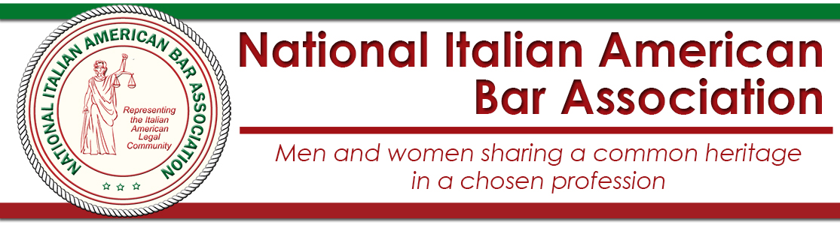
1 HOUR MCLE
General Meeting with the National Italian American Bar Association
featuring

Joe Sena, Esq.

“Terror, Terrorism, and Terrible: A Walk in the Never Never Land of Contemporary U.S. Immigration Law”
A discussion of new immigration law changes and their impact on criminal, family, and probate law.
FEBRUARY 15, 2017
6:00 pm: Cocktails and Music
7:00 pm – 9:00 pm: Dinner and Program

Entrée Selection: Chicken, Sausage & Peppers, or Vegetarian Eggplant Parmesan
All dinners come with Antipasto, Mostaccioli, Spumoni, and Wine

RSVP by February 13th at our Event Page: http://iala38.wildapricot.org/page-1836071
Meal selections not guaranteed after the RSVP deadline.

Prices:
Non-Members: $50 with RSVP and payment received prior to the event
IALA Members & Retired Judges: $45 with RSVP and payment received prior to the event
Sitting Judges: Free! / Students: $25 / Tables of 8: $360
All payments at the door will be $10 more than the above-listed prices.
Payment:
Pay via PayPal at the link above where you RSVP or Mail checks to
IALA, PO Box 712057, Los Angeles, CA 90071, but still RSVP online.

Questions or feedback? E-mail us at iala07@yahoo.com.

